**Pig - II**

**Student Name: Student Id:**

**Date:**

Please use the screenshots ONLY as a reference. The written instructions must be followed AS written.

PLEASE MAKE SURE YOU SUBMIT ALL THE SCREENSHOTS WITH TIMESTAMPS AT THE BOTTOM RIGHT (WINDOWS USERS) OR THE TOP RIGHT (MAC OSX USERS) OR ELSE YOU WILL AUTOMATICALLY QUALIFY FOR A DISCOUNT.

# Objective:

Pig is an engine for executing data flows in parallel on Apache Hadoop. It is used to read, process and store massive amounts of data. The objective of this exercise is to help the student become familiar with Pig. We will load the data in Pig and view it in HDFS.

**NOTE:**

* **Code to be executed is highlighted in Green**
* **The explanation for all the code is provided below the code**
* **There are subtle differences in HDFS commands and common Linux commands, if you are running into an error, or not seeing what you expect double check the commands**
* **The directory structure of HDFS has nothing to do with the directory structure of the local file system**
* **Some commands contain a (\) at the end of the first line, this signifies that the command is not complete. You may enter the code as it is shown on two lines or on one line without the “\”**
* **Maximize the terminal screen and increase the font to a visible size, otherwise points will be deducted**

Table of Contents

Objective: 1

Part-1: Pig Latin: 3

Part-2: Pig Script: 13

Part-3: Checksum: 14

ADDITIONAL NOTES: 17

Part-1: Pig Latin: In this section we will setup the necessary data files for this assignment.

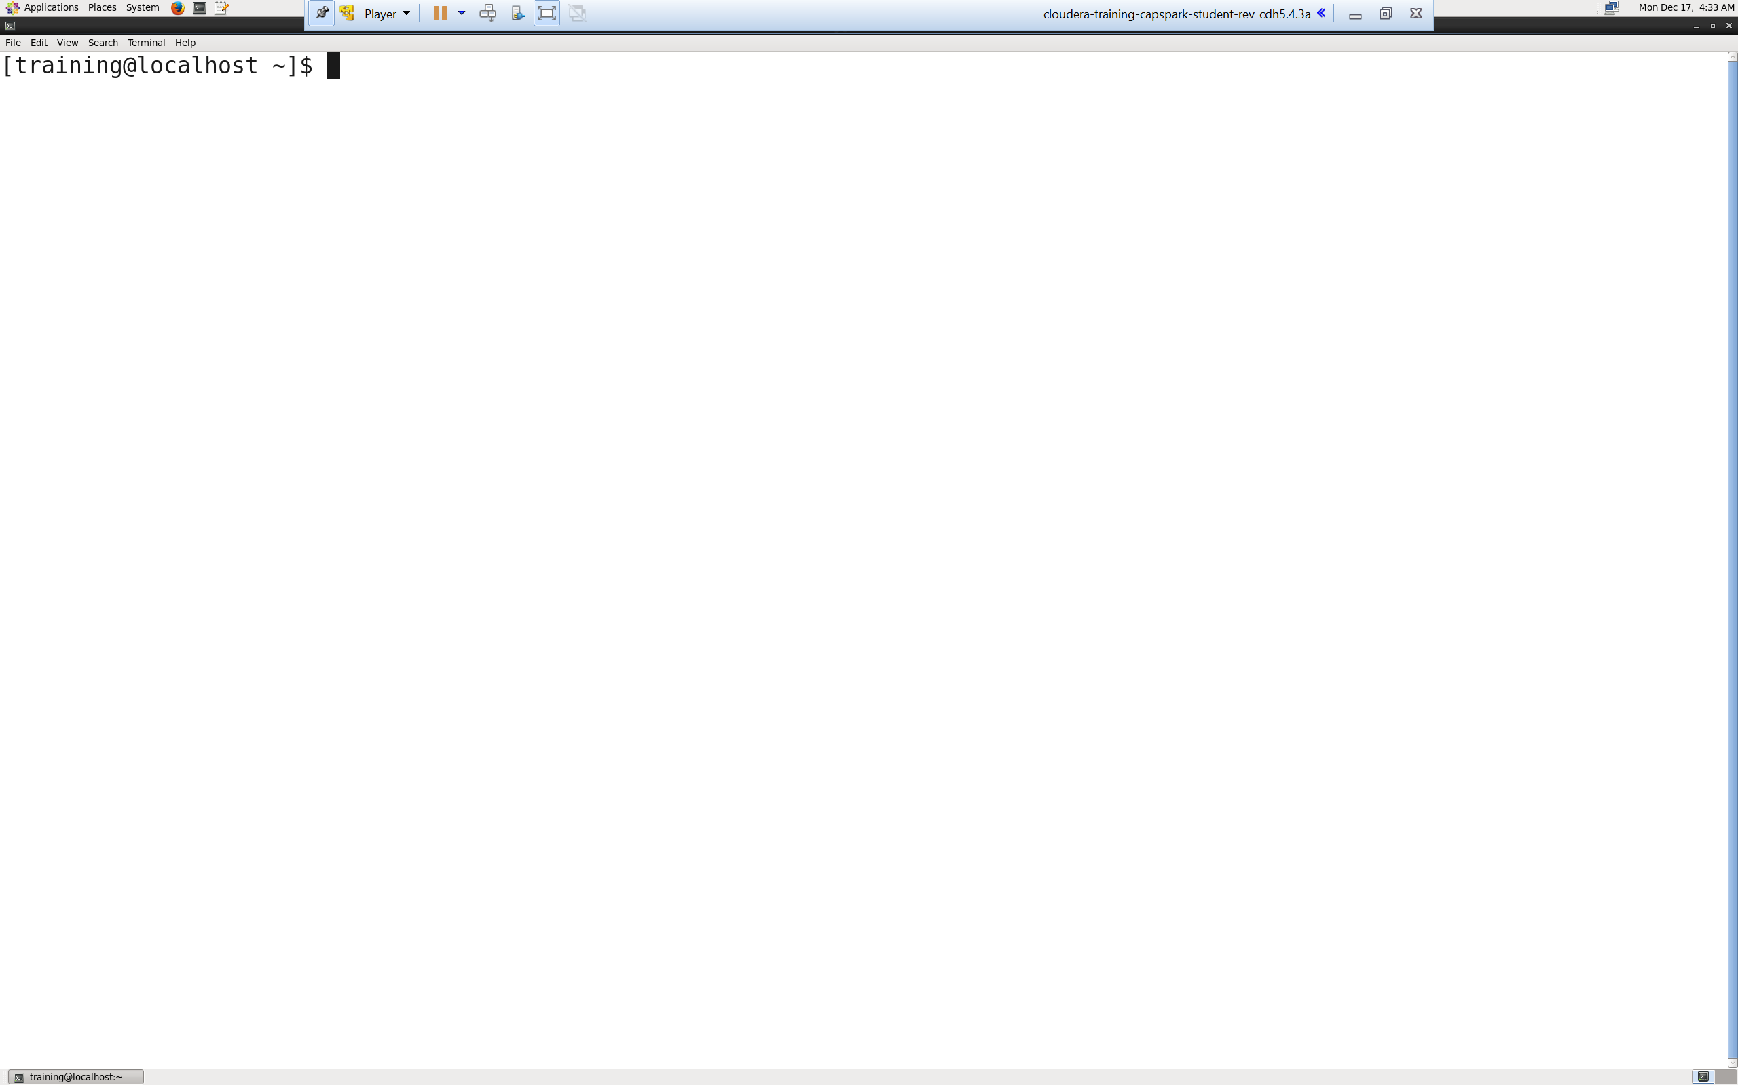Step-1: Start the Cloudera VM and then launch the “terminal” application.

Q. Take a screenshot of the terminal and paste it below.

Step-2: Download the data.zip file from eLearning in to the downloads folder IN the Cloudera VM using Mozilla Firefox.

Step-3: Execute the following command:





Q. Now type the command and execute. Take a screenshot of the shell output, highlight the zip file that we downloaded and paste it below.

Step-4: Execute the following command at the shell prompt:



Q. Now type the  command and execute. Take a screenshot of the shell output, highlight the contents of the zip file and paste it below.

Explanation: The “unzip” command unzips the zip file.

Step-5: Next place the data into Hadoop by executing below 3 commands at the shell prompt



Q. Now type the below command and execute. Take a screenshot of the shell output and paste it below.



Explanation: The “put” command is used to copy a local file or directory into HDFS. We are copying the file from our local directory to the HDFS in the Firstname_data directory.

NOTE:

* Replace Firstname with your first name, DO NOT copy as is.

Step-6: Execute the following command at the shell prompt:



Q. Take a screenshot of the shell output and paste it below.

Explanation: Grunt is Pig’s interactive shell program. It is used to interact with HDFS directly. To enter Grunt type pig.

NOTE:

* To exit type quit or press <ctrl-d>

Step-7: Execute the following 2 command at the shell prompt:





Explanation: We are loading flight and airport data from csv into hdfs using pig commands.

Command 1: We are loading the data from flights.csv file into variable flights. All columns from csv are mapped into hdfs. By default, Pig uses the PigStorage () load function.

Command 2: We are loading the data from airports.csv file into variable airports. All columns from csv are mapped into hdfs. By default, Pig uses the PigStorage () load function.

NOTE:

* Replace Firstname with your first name, DO NOT copy as is.
* Please maintain the code from Step7-15 in a text file as you will be using this code again to configure pig script later in the assignment.

Q. Take a screenshot of the shell output and paste it below.

Step-8: Execute the following command at the shell prompt:



Q. Now type the below 2 command and execute. Take a screenshot of the shell output and paste it below. How many numbers of airports are there in Texas?



Explanation: We are filtering airports to those only in Texas. The result is stored in variable airports_filtered.

Step-9: Execute the following command at the shell prompt:



Q. Take a screenshot of the shell output and paste it below.

Explanation: Calculate updated actual departure time and arrival time and store the dataset in updated_time variable.

UPDATED_DEPART_TIME : We are deducting scheduled_departure time from departure_time column and if the result is less than -60, then we replace value of the column as departure_time + 60 or else replace it by departure_time. This is done to counter the effect of column values in respective columns which hold values as 24 hours clock.

UPDATED_ARRIVAL_TIME : We are deducting scheduled_arrival time from arrival_time column and if the result is less than -60, then we replace value of the column as arrival_time + 60 or else replace it by arrival_time. This is done to counter the effect of column values in respective columns which hold values as 24 hours clock.

Step-10: Execute the following command at the shell prompt:



Q. Take a screenshot of the shell output and paste it below.

Explanation: The calculated fields Departure delay and Arrival delay are calculated using the columns created in above step. The result will be stored in flight_with_delay.

DEPARTURE_DELAY : Subtract scheduled departure time from updated depart time which we calculated in the above step, if the result is greater than 0 then update the column DEPARTURE_DELAY as result of UPDATED_DEPART_TIME – SCHEDULED_DEPARTURE or else update the column value with 0.

ARRIVAL_DELAY : Subtract scheduled arrival time from updated arrival time which we calculated in the above step, if the result is greater than 0 then update the column ARRIVAL_DELAY as result of UPDATED_ARRIVAL_TIME – SCHEDULED_ARRIVAL or else update the column value with 0.

Step-11: Execute the following command at the shell prompt:



Q. Take a screenshot of the shell output and paste it below.

Explanation: We are filtering out the nulls in delay time. We are storing the result in flight_with_delay_no_null.

Step-12: Execute the following command at the shell prompt:



Q. Take a screenshot of the shell output and paste it below.

Explanation: Group the result by year, month, airport and airline

Step-13: Execute the following command at the shell prompt:



Q. Take a screenshot of the shell output and paste it below.

Explanation: We are using nested foreach and non-linear processing or derived

data set.

Line 1-2: We are loading the data into summary_data variable. Firstly, we are calculating average departure delay

Line 3: Limit data set to a delay greater than 20 min

Line 4-5: Calculate the min and max departure delay

Line 6-7: Remove the level of nesting using flatten creating a cross product of every value calculated in above steps

Step-14: Execute the following command at the shell prompt:





Q. Take a screenshot of the shell output and paste it below.

Explanation: We want to now add airport information to the flight delay data. We’ll do this through a replicated join. Replicated join is used for joining a large data set to a small data set. Describe lists expected output columns.

Step-15: Execute the following 2 command at the shell prompt:

Q. Take a screenshot of the shell output and paste it below.

Explanation: We will sort the data by origin airport, year and month and print the output on console.

NOTE:

* To exit type quit or press <ctrl-d>

Part-2: Pig Script: In this section we are going to create a pig script

Step-16:Create a new pig file in downloads folder. Press <Ctrl+d>. Then type below command on shell prompt:



Q. Take a screenshot of the shell output and paste it below.

Step-17: Press i to insert. Copy the code from Step 7 – 14 into the file. Replace value of 20 in nested foreach by $DELAY.

Then replace the dump line by below code.



Q. Take a screenshot of the shell output and paste it below. The entire script should be visible in snap shot.

Explanation: Store the output of our script into Firstname_data folder. The name of folder will be the value that we will pass (value_final).

NOTE:- Do not copy the below lines code in the script that we are configuring in Step17



* Exit from vi editor

Step-18: Execute the following command at the shell prompt:





Q. Take a screenshot of the shell output and paste it below. Describe the meaning of the output that you see ?

Explanation: pass value 30 in delay parameter. It will replace the value of 20 in pig script and store the result in the folder specified in store command that is the last line we created in our code.

NOTE:

* Replace Firstname_Lastname with your first name and last name.

Step-19: Execute the following command at the shell prompt:



Q. Take a screenshot of the shell output and paste it below. Describe the meaning of the output that you see ?

Explanation: The above code will display the output of our script which is stored in 30_final folder. The output will be the dataset containing records where departure delay is greater than 30 min.

NOTE:

* Replace Firstname with your first name.

Part-3: Checksum: In this section we will perform a checksum

Step-20: Download the Checksum.zip file from eLearning in to the downloads folder **IN** the Cloudera VM using Mozilla Firefox.

Step-21: Execute the following command:



Q. Now type the command and execute. Take a screenshot of the shell output, highlight the zip file and paste it below.

Step-22: Execute the following command at the shell prompt:



Q. Now type the command and execute. Take a screenshot of the shell output, highlight the contents of the zip file and paste it below.

Explanation: The “unzip” command unzips the zip file.

Step-23: Execute the following command at the shell prompt:

Then execute the following command:

Q. Take a screenshot of the shell output and paste it below.

Step-24: Execute the following command at the shell prompt:

rm Checksum.zip checksum.sh output.txt



Q. Now type the command and execute. Take a screenshot of the shell output and paste it below.

# ADDITIONAL NOTES:

* Make sure to check the spelling before you execute a command, a spelling mistake in one step can snowball and prevent other steps from working.
* Execute means, type in the given command and hit return/enter
* Shell output refers to the output that you see in the terminal application after executing a command
* **SUBMIT A WORD DOCUMENT CONTAINING YOUR SCREENSHOTS IN ELEARNING.**
* **Also submit the Checksum value (32-bit alpha numeric key) from Step-23 in the comments section of the submission as shown in the screenshot below:**

